**Date: 09-08-2021**

**Experiment 2**

**Aim:** To perform scalar and array operations on MATLAB variables, arrays, multi-dimensional arrays, sub-arrays.

**Apparatus:** MATLAB Software

**Objective:**

1. To learn how different library functions can be used with arrays and multi-dimensional arrays.
2. To learn how specific elements of an array can be accessed and utilized in coding.

**Problems:**

**Q-1.** Answer the following questions for the array shown here.



(*a*) Determine the size of an array1.

(*b*) Determine the value of an array1(1,4).

(*c*) Determine the size and value of an array1(:,1:2:5).

(*d*) Determine the size and value of an array1([1 3],end).

**MATLAB Program:**

**Code:**

clc;

clear all;

close all;

A = [0.0 0.5 2.1 -3.5 6.0; 0.0 -1.1 -6.6 2.8 3.4; 2.1 0.1 0.3 -0.4 1.3; 1.1 5.1 0.0 1.1 -2.0];

size(A)

A(1,4)

A(:,1:2:5)

size(A(:,1:2:5))

A([1 3],end)

size(A([1 3],end))

**Output:**

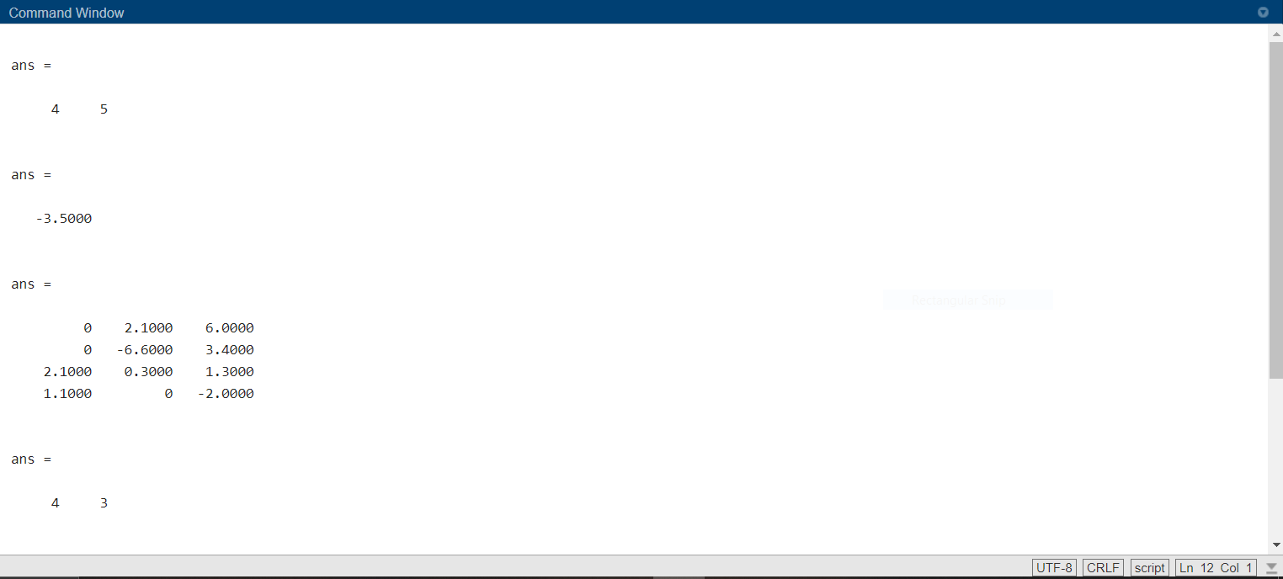

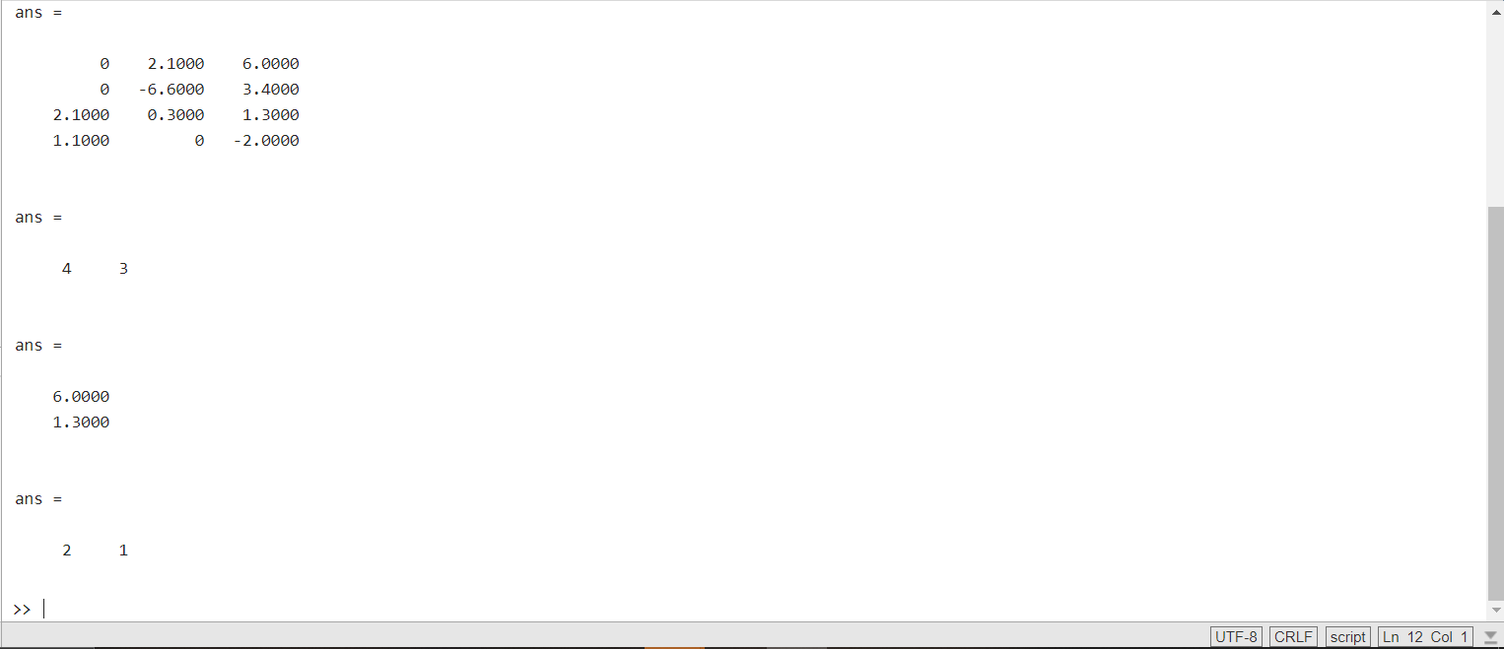

**Q-2.** Are the following MATLAB variable names legal or illegal? Why?

|  |  |  |
| --- | --- | --- |
| **Variable Name** | **Validity** | **Reason** |
| dog1 | Valid | As we can use both alphabets and numbers |
| 1dog | Invalid | We can’t start a variable name with numerical value |
| Do_you_know_the_way_to_san_jose | Valid | We can use both alphabets and ‘__’ |
| _help | Invalid | We can’t start with a ‘__’ |
| What's_up? | Invalid | Only alphanumeric with ‘__’ is valid. |

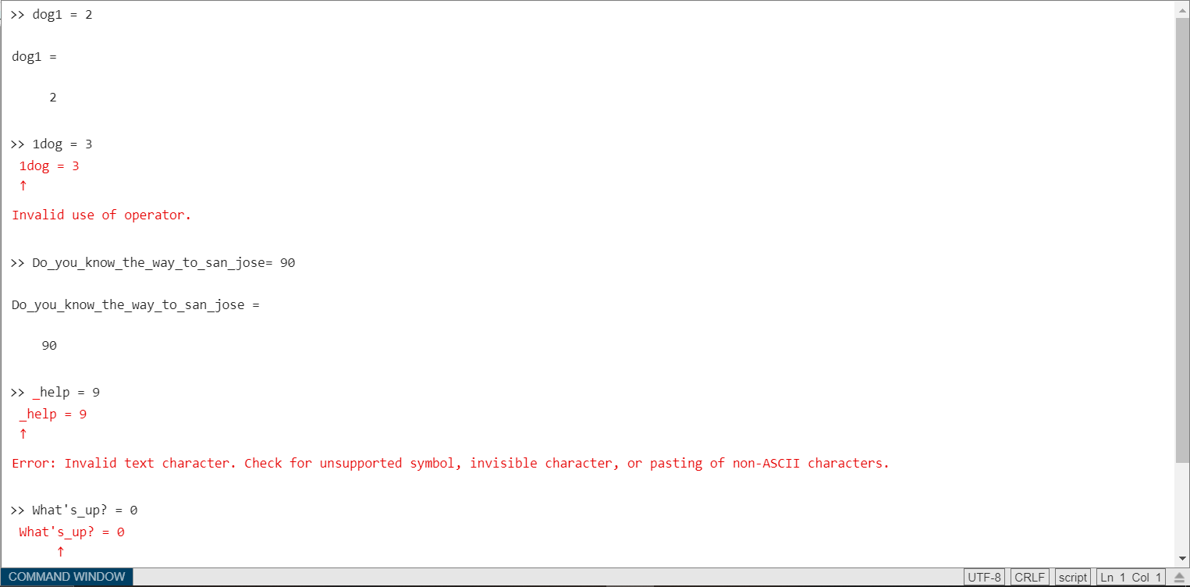

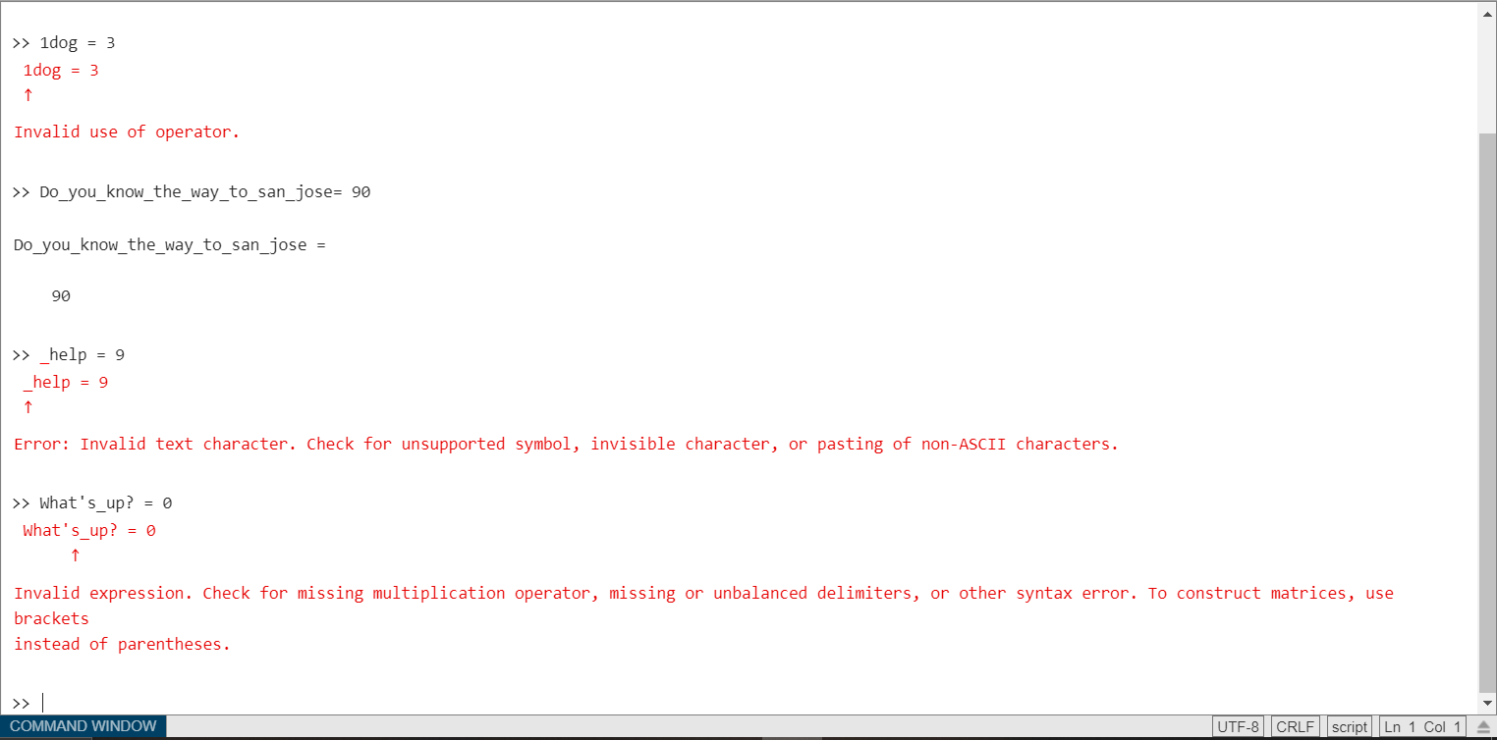

**Q-3.** Determine the size and contents of the following arrays. Note that the later arrays may depend on the definitions of arrays defined earlier in this exercise.

(*a*) a = 2:3:8;

(*b*) b = [a' a' a'];

(*c*) c = b(1:2:3,1:2:3);

(*d*) d = a + b(2,:);

(*e*) w = [zeros(1,3) ones(3,1)' 3:5'];

(*f* ) b([1 3],2) = b([3 1],2);

(*g*) e = 1:-1:5;

**Code:**

clc;

clear all;

close all;

a = 2:3:8

size(a)

b = [a' a' a']

size(b)

c=b(1:2:3,1:2:3)

size(c)

d = a+b(2,:)

size(d)

w = [zeros(1,3) ones(3,1)' 3:5']

size(w)

b([1 3],2) = b([3 1],2)

e = 1:-1:5

k = 3:5'

**Output:**

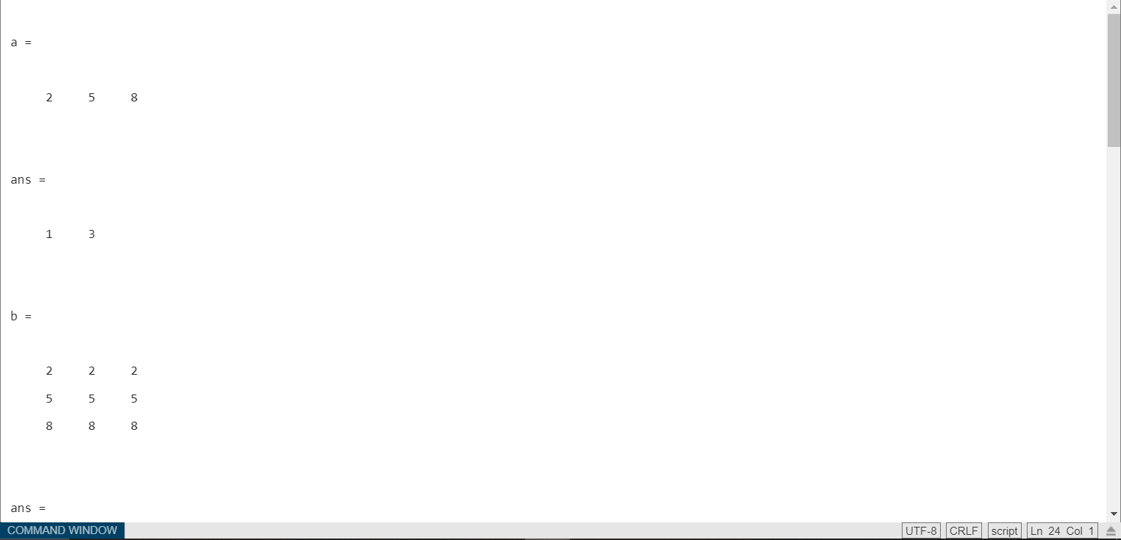

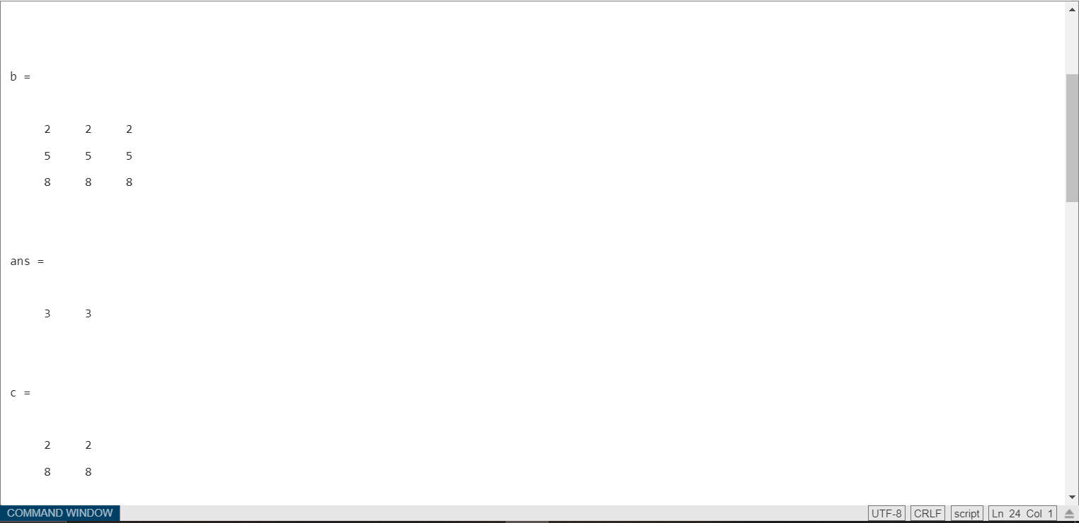

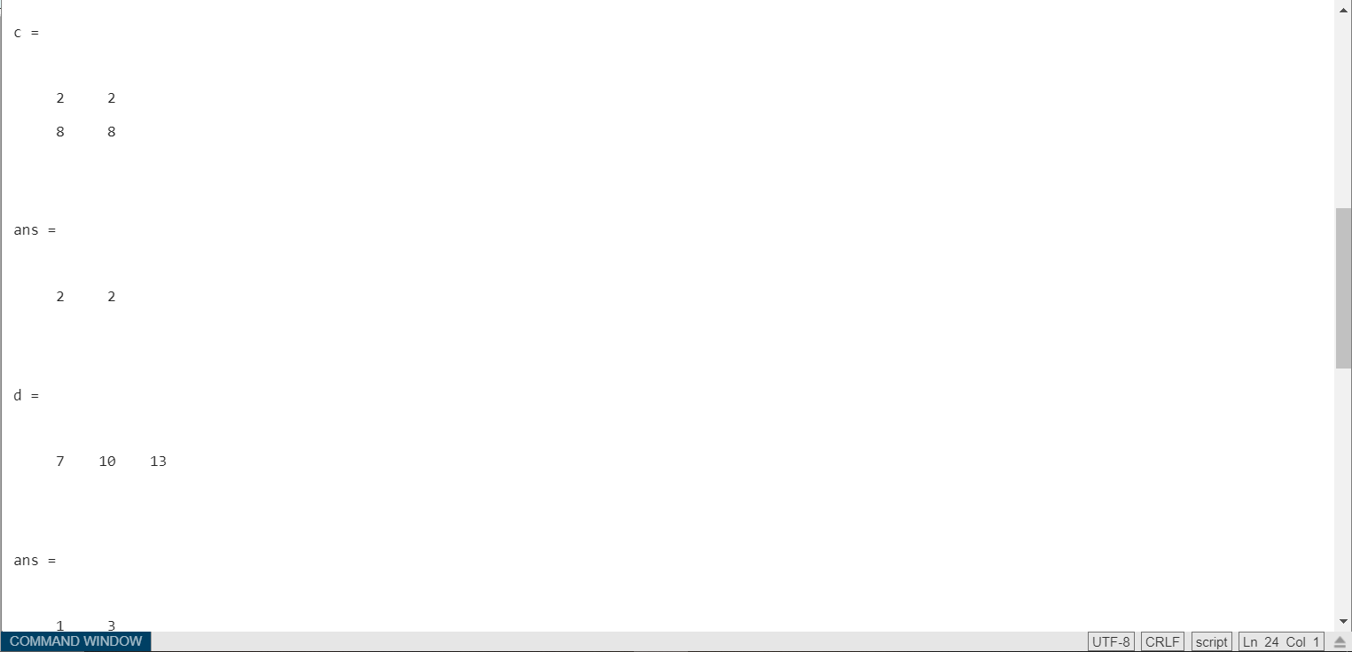

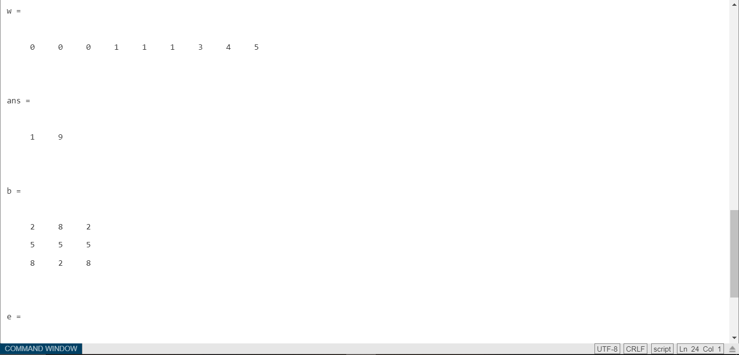

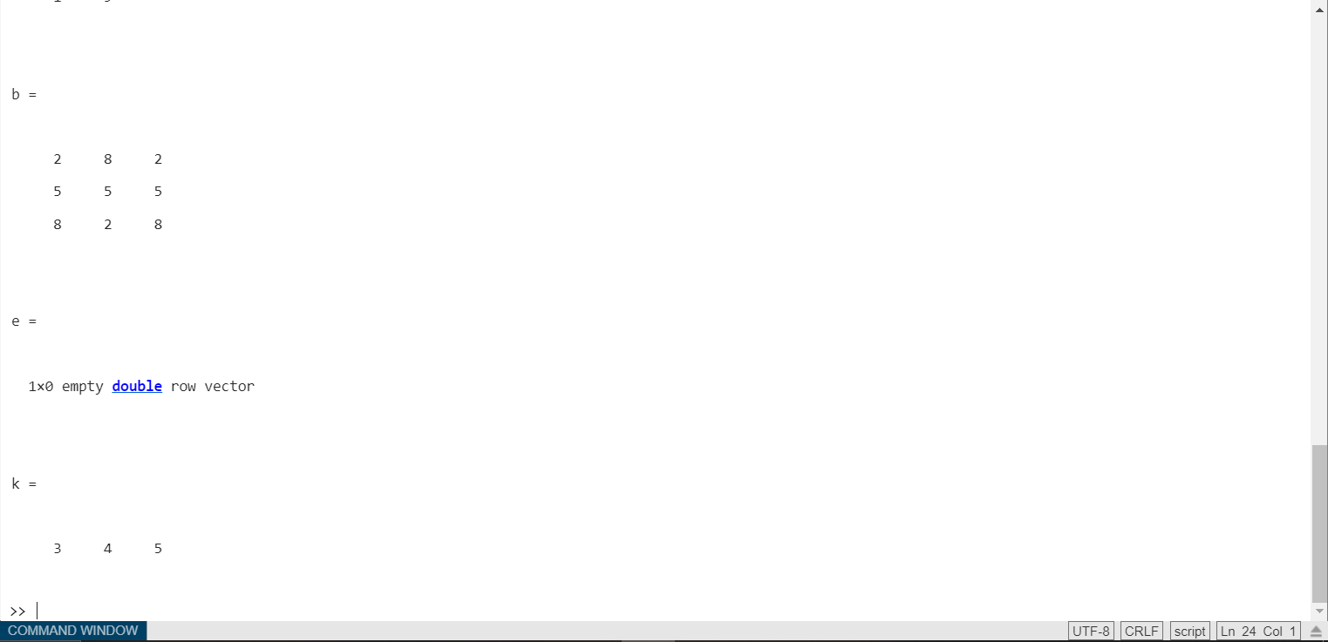

**Q-4.** Assume that a, b, c, and d are defined as follows, and calculate the results of the following operations in MATLAB if they are legal. If an operation is illegal, explain why it is illegal.



(*a*) result = a + b;

(*b*) result = a * d;

(*c*) result = a .* d;

(*d*) result = a * c;

(*e*) result = a .* c;

(*f* ) result = a \ b;

(*g*) result = a .\ b;

(*h*) result = a .^ b;

**Code:**

clc;

clear all;

close all;

a= [2 1

-1 4]

b = [-1 3

0 2]

c = [2

1]

d= eye(2)

r = a+b

r1 = a* d

r2 = a.*d

r3 = a*c

r4 = a.*c

r5 = a\b

r6 = a.\b

r7 = a/b

r8 = a./b

r9 = a.^b

**Output:**

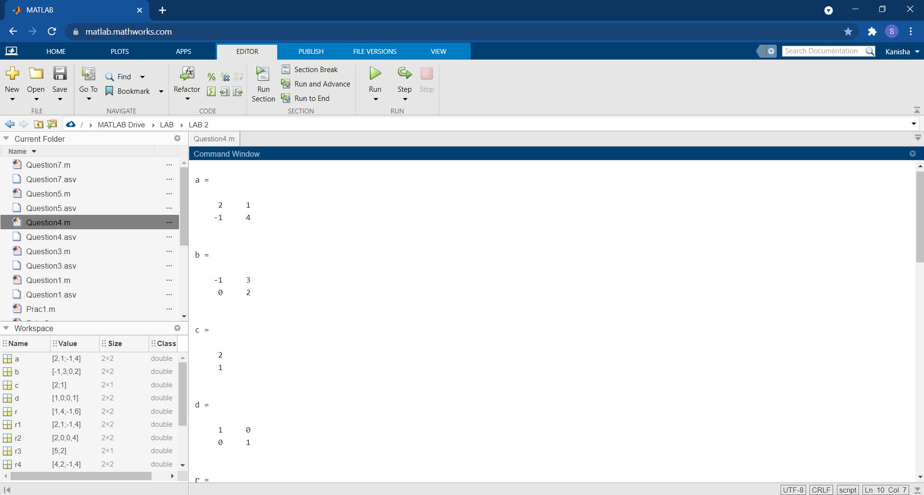

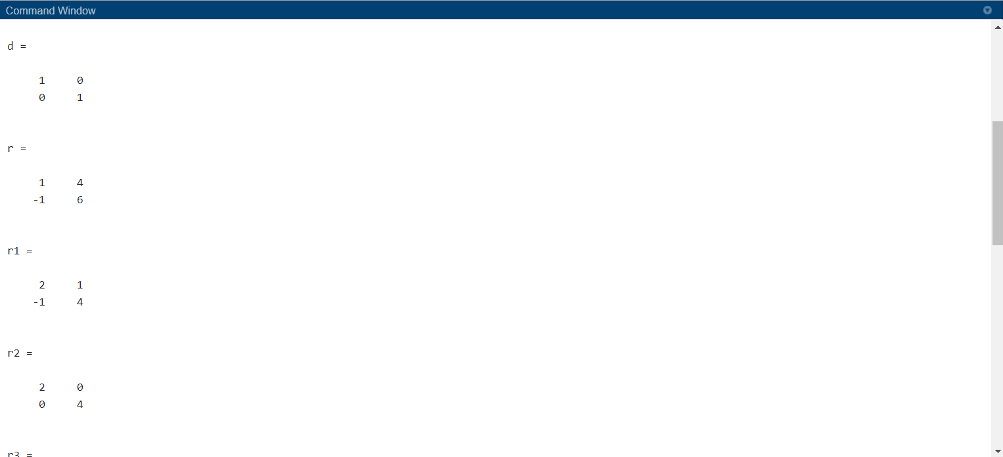

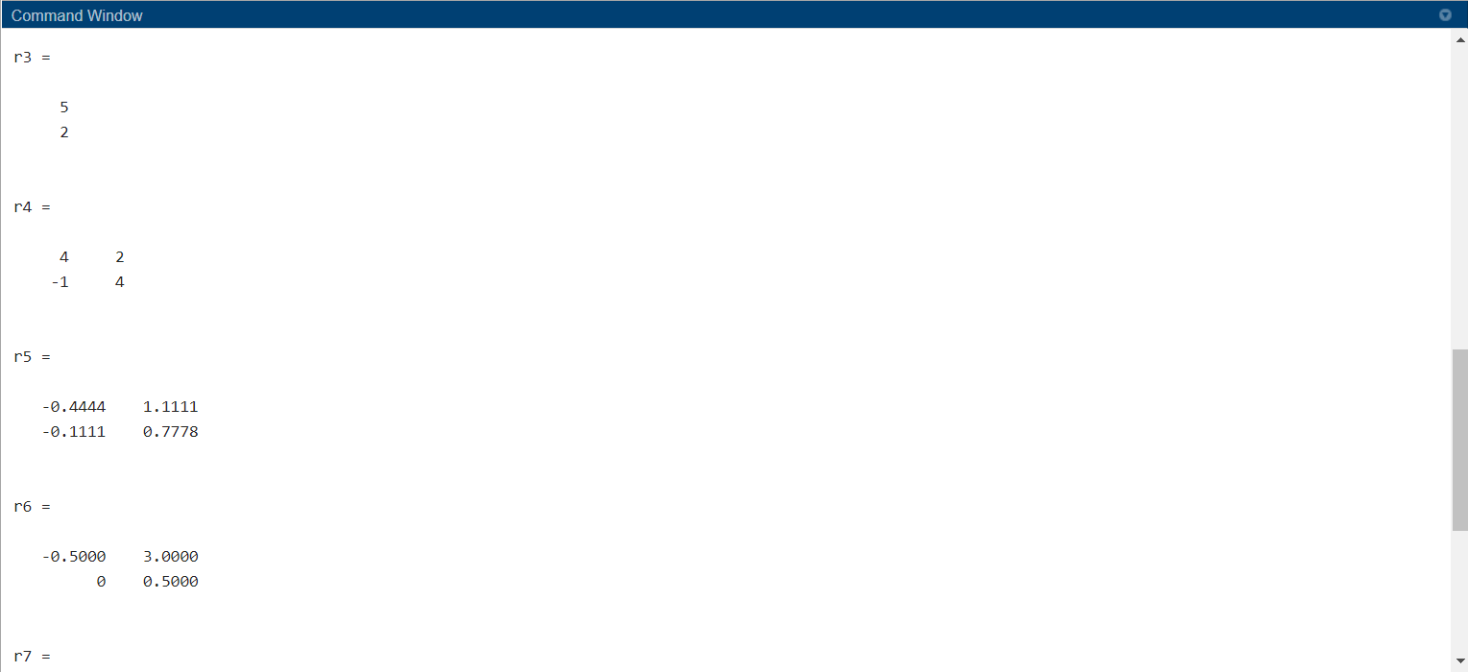

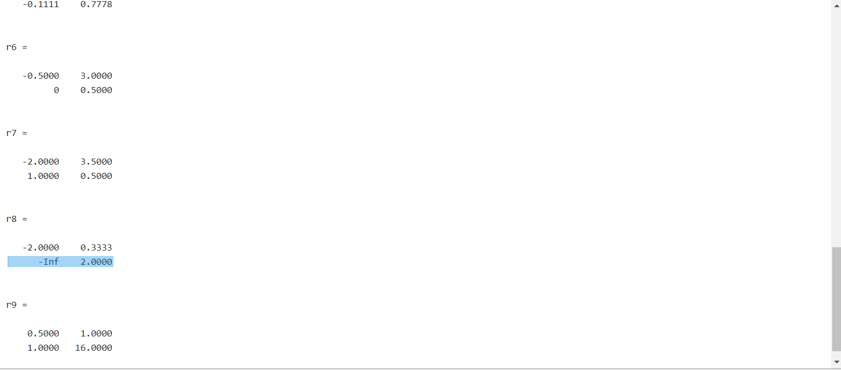

**Q-5.** Evaluate each of the following expressions in MATLAB:

(*a*) 11 / 5 + 6

(*b*) (11 / 5) + 6

(*c*) 11 / (5 + 6)

(*d*) 3 ^ 2 ^ 3

(*e*) 3 ^ (2 ^ 3)

(*f* ) (3 ^ 2) ^ 3

(*g*) round(-11/5) + 6

(*h*) ceil(-11/5) + 6

(*i*) floor(-11/5) + 6

**Code:**

clc;

clear all;

close all;

a = 11/5+6

b = (11/5) +6

c = 11/(5+6)

d = 3 ^ 2 ^ 3

e = 3 ^ (2 ^ 3)

f = (3 ^ 2) ^ 3

g = round(-11/5) + 6

h = ceil(-11/5) + 6

i = floor(-11/5) + 6

**Output:**

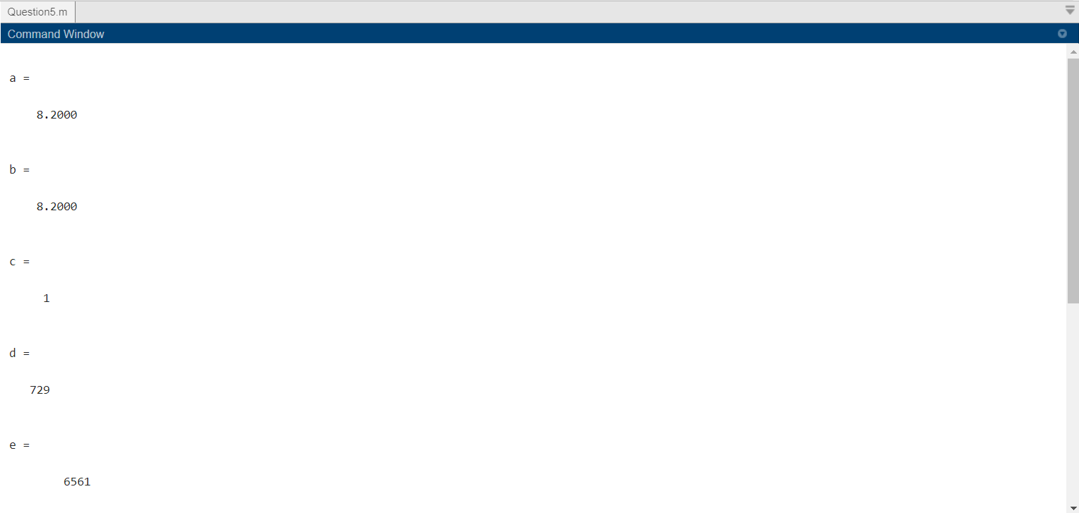

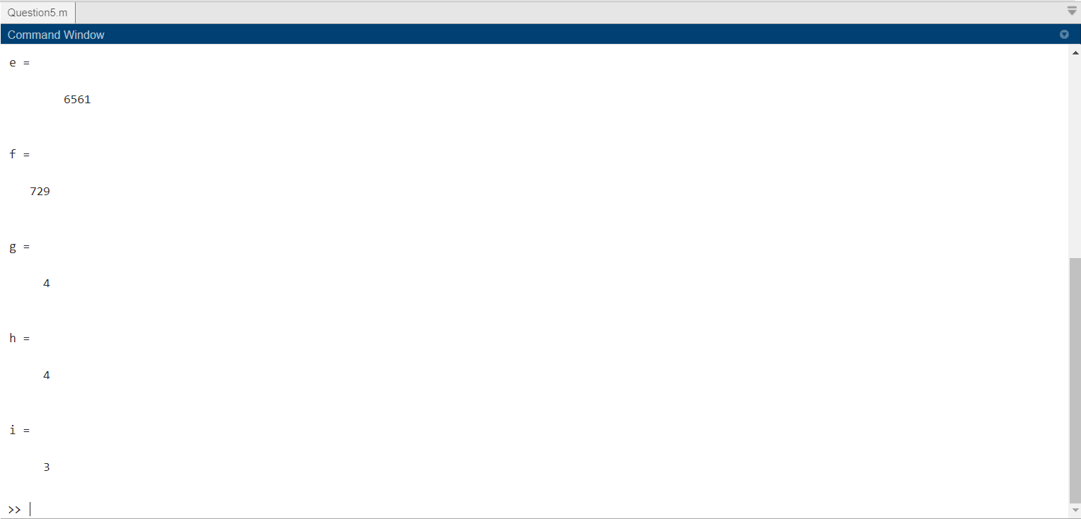

**Q-6.** The distance between two points (*x*1, *y*1) and (*x*2, *y*2) on a Cartesian coordinate plane is given by the equation,



Write a program to calculate the distance between any two points (*x*1, *y*1) and (*x*2, *y*2) specified by the user. Use good programming practices in your program. Use the program to calculate the distance between the points (-3, 2) and (3, -6).



**Code:**

clc;

clear all;

close all;

s = "Enter value of x1:";

x1 = input(s);

s = "Enter value of x2:";

x2 = input(s);

s = "Enter value of y1:";

y1 = input(s);

s = "Enter value of y2:";

y2 = input(s);

d = sqrt((x1-x2)^2 + (y1-y2)^2)

**Output:**

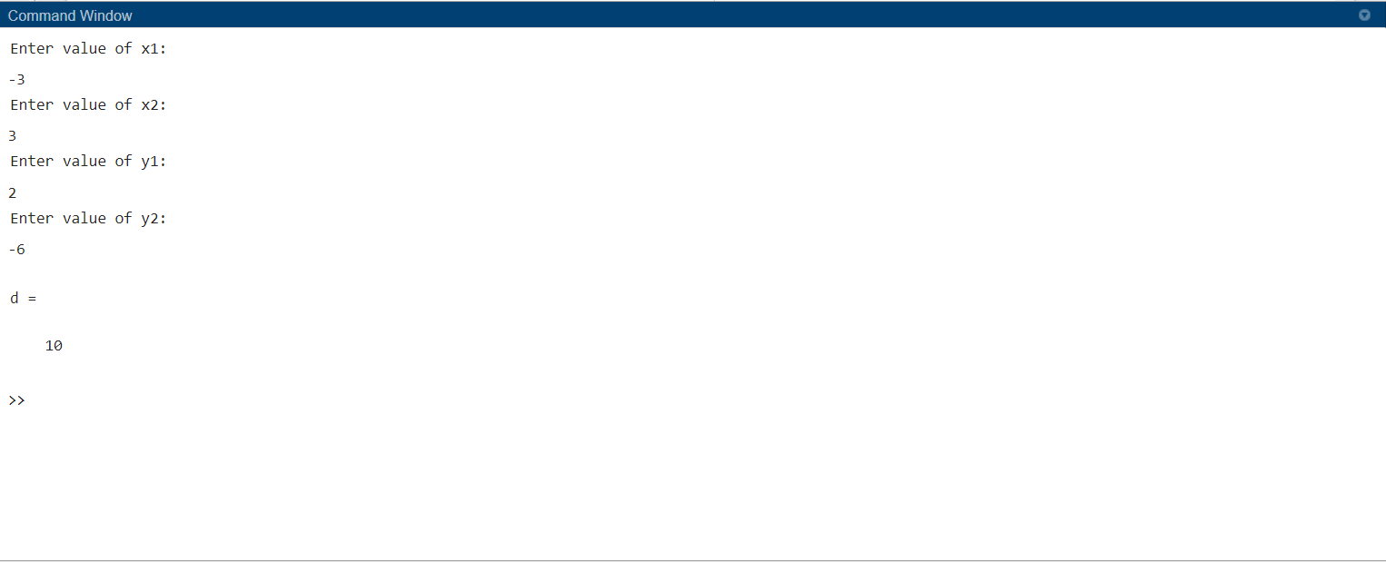

**Conclusion:**

From this lab I came to understand different ways to use arrays, its variable validity. I got my hands on practice for basics of precedence rule in MATLAB for operators and even using different inbuilt functions of MATLAB.

**Post-Lab Problems**

**Q-1.** Engineers often measure the ratio of two power measurements in *decibels*, or dB. The equation for the ratio of two power measurements in decibels is



where *P*2 is the power level being measured, and *P*1 is some reference power level.

(*a*) Assume that the reference power level *P*1 is 1 milliwatt, and write a program that accepts an input power *P*2 and converts it into dB with respect to the 1 mW reference level. (Engineers have a special unit for dB power levels with respect to a 1 mW reference: dBm.) Use good programming practices in your program.

(*b*) Write a program that creates a plot of power in watts versus power in dBm with respect to a 1 mW reference level. Create both a linear *xy* plot and a log-linear *xy* plot.

**Code:**

clc;

clear all;

close all;

s = "Enter value of P1:";

P1 = input(s);

s = "Enter value of P2:";

P2 = input(s);

dB = 10 * log10(P2/P1)

s = "Enter value of P2 in Array:";

P2a = input(s);

dBa = 10 * log10(P2a)

plot(P2a,dBa)

title("Linear Graph")

xlabel('P2')

ylabel('dB')

figure

semilogx(P2a,dBa)

title("Semi Logarithmic Linear Graph")

xlabel('log(P2)')

ylabel('dB')

**Output:**

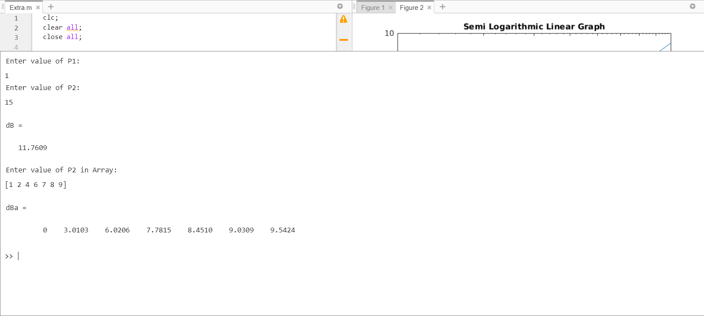

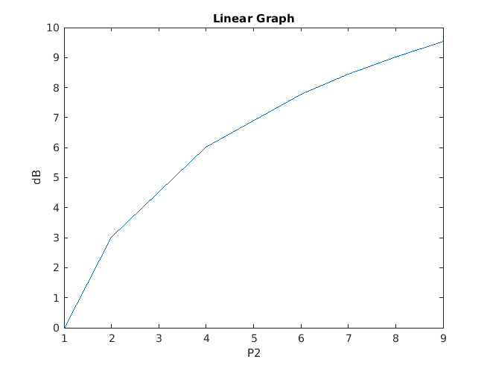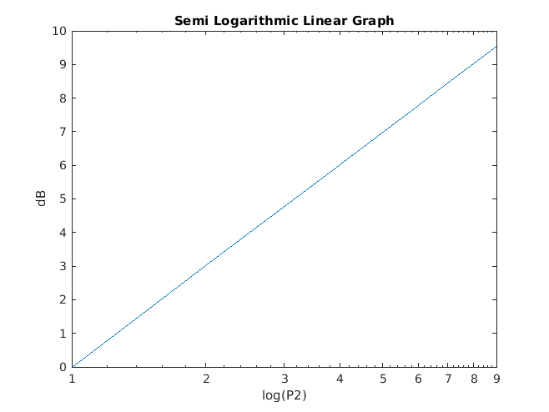

**Q-2.** The voltage across a resistor is related to the current flowing through it by Ohm’s law



and the power consumed in the resistor is given by the equation



Write a program that creates a plot of the power consumed by a 1000 Ω resistor as the voltage across it is varied from 1 V to 200 V. Create two plots, one showing power in watts, and one showing power in dBW (dB power levels with respect to a 1 W reference).



**Code:**

clc;

clear all;

close all;

s = "Enter value of R(ohm):";

R = input(s);

V = 1:10:200;

I = V/R;

P=I.*V;

figure

plot(V,P)

title("V vs P (W)")

xlabel('Voltage')

ylabel('Power')

dB = 10 * log10(P);

figure

plot(V,dB)

title("V vs P (dB)")

xlabel('Voltage')

ylabel('Power')

**Output:**

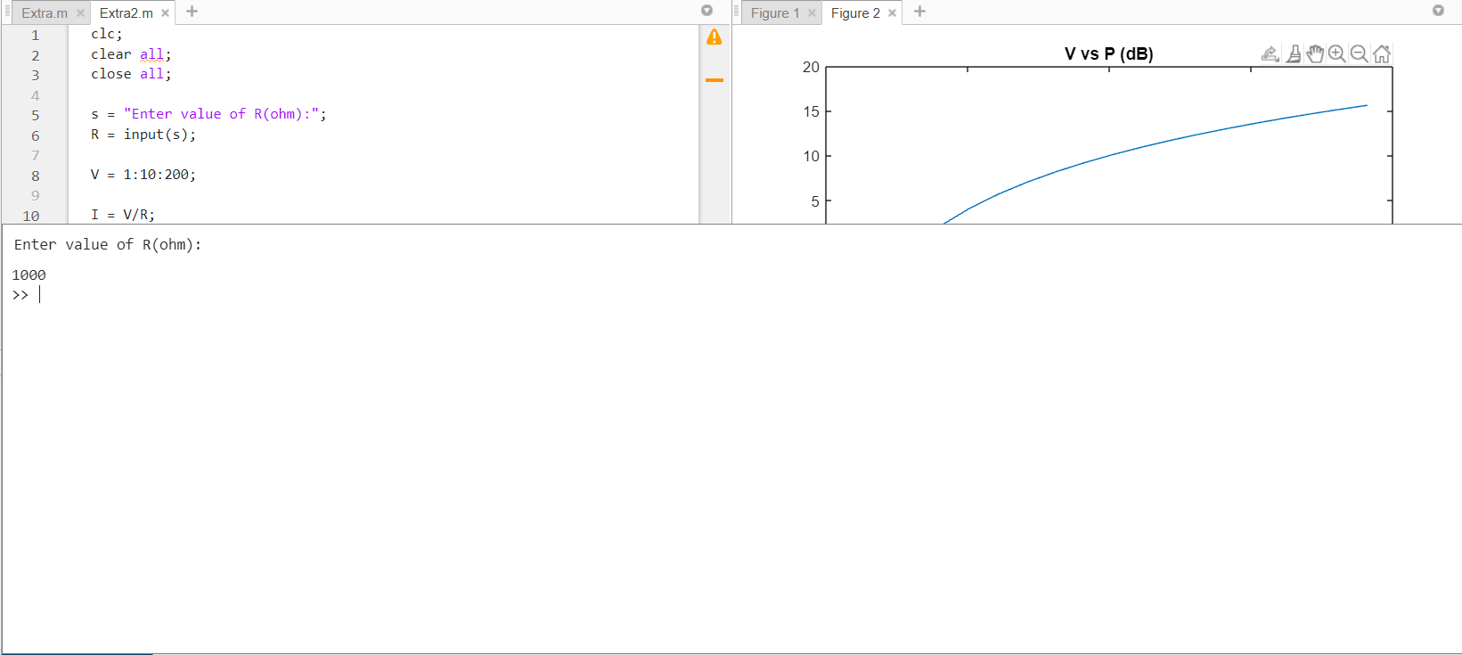

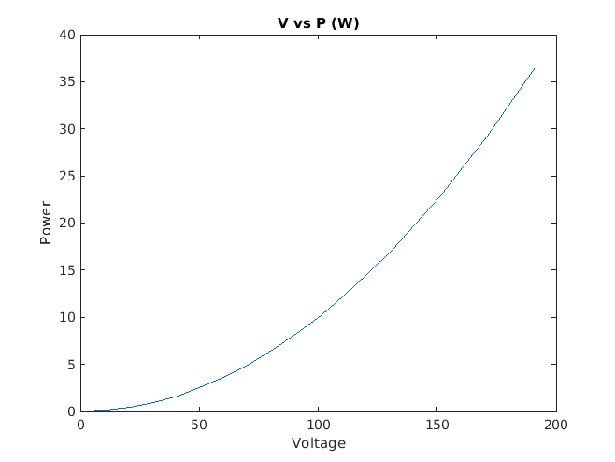

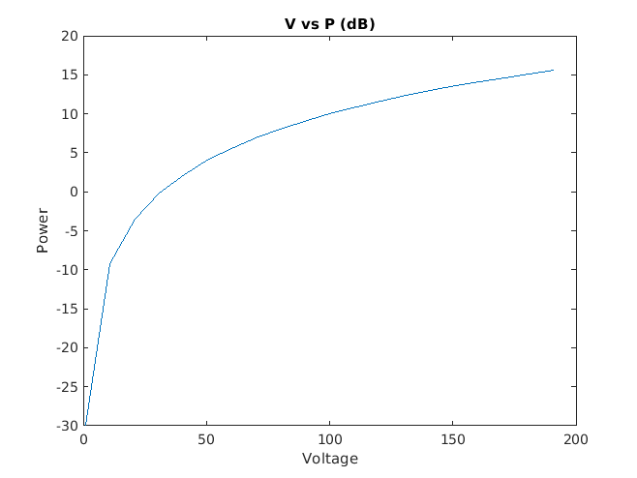

**Q-3.** The force required to compress a linear spring is given by the equation



where *F* is the force in newtons and *k* is the spring constant in newtons per meter. The potential energy stored in the compressed spring is given by the equation



where *E* is the energy in joules. The following information is available for four springs:



Determine the compression of each spring, and the potential energy stored in each spring. Which spring has the most energy stored in it?

**Code:**

clc;

clear all;

close all;

F = [20 30 25 20];

k = [200 250 300 400];

%Compression of Spring

x = F./k;

fprintf('\nCompression of Spring: ')

fprintf('%.3f\t', x)

%potential Energy

E = 0.5 * (k .* (x.^2));

fprintf('\n\nPotential Energy of Spring: ')

fprintf('%.3f\t', E)

%Maximum of them

fprintf('\n\nMaximum Energy of Spring: ')

fprintf('%.3f\t', max(E))

**Output:**

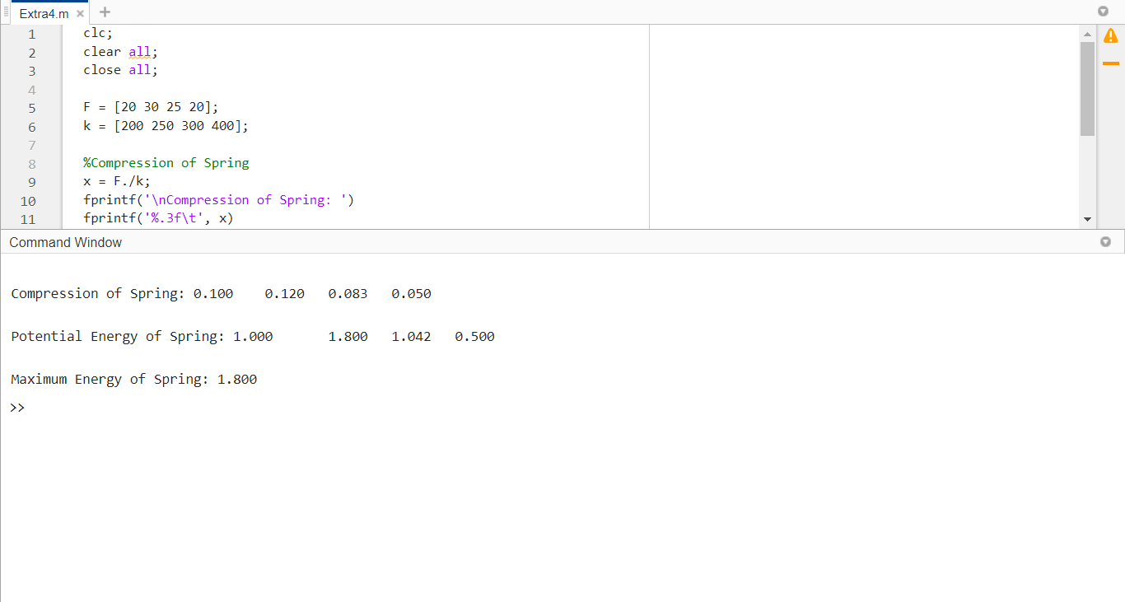

**Q-4.** A simplified version of the front end of an AM radio receiver is shown in below figure. This receiver consists of an *RLC* tuned circuit containing a resistor, capacitor, and an inductor connected in series. The *RLC* circuit is connected to an external antenna and ground as shown in the picture. The tuned circuit allows the radio to select a specific station out of all the stations transmitting on the AM band. At the resonant frequency of the circuit, essentially all of the *V0* signal appearing at the antenna appears across the resistor, which represents the rest of the radio. In other words, the radio receives its strongest signal at the resonant frequency. The resonant frequency of the LC circuit is given by the equation



where *L* is inductance in henrys (H) and *C* is capacitance in farads (F). Write a program that calculates the resonant frequency of this radio set

given specific values of *L* and *C*. Test your program by calculating the frequency of the radio when *L* = 0.25 mH and *C =* 0.10 nF.



**Code:**

clc;

clear all;

close all;

s = "Enter value of L(mH):";

L = input(s);

s = "Enter value of C(nF):";

C = input(s);

%L = 0.25E03;

%C = 0.1E09;

f0 = 1/(2 * pi * sqrt(L*C))

**Output:**

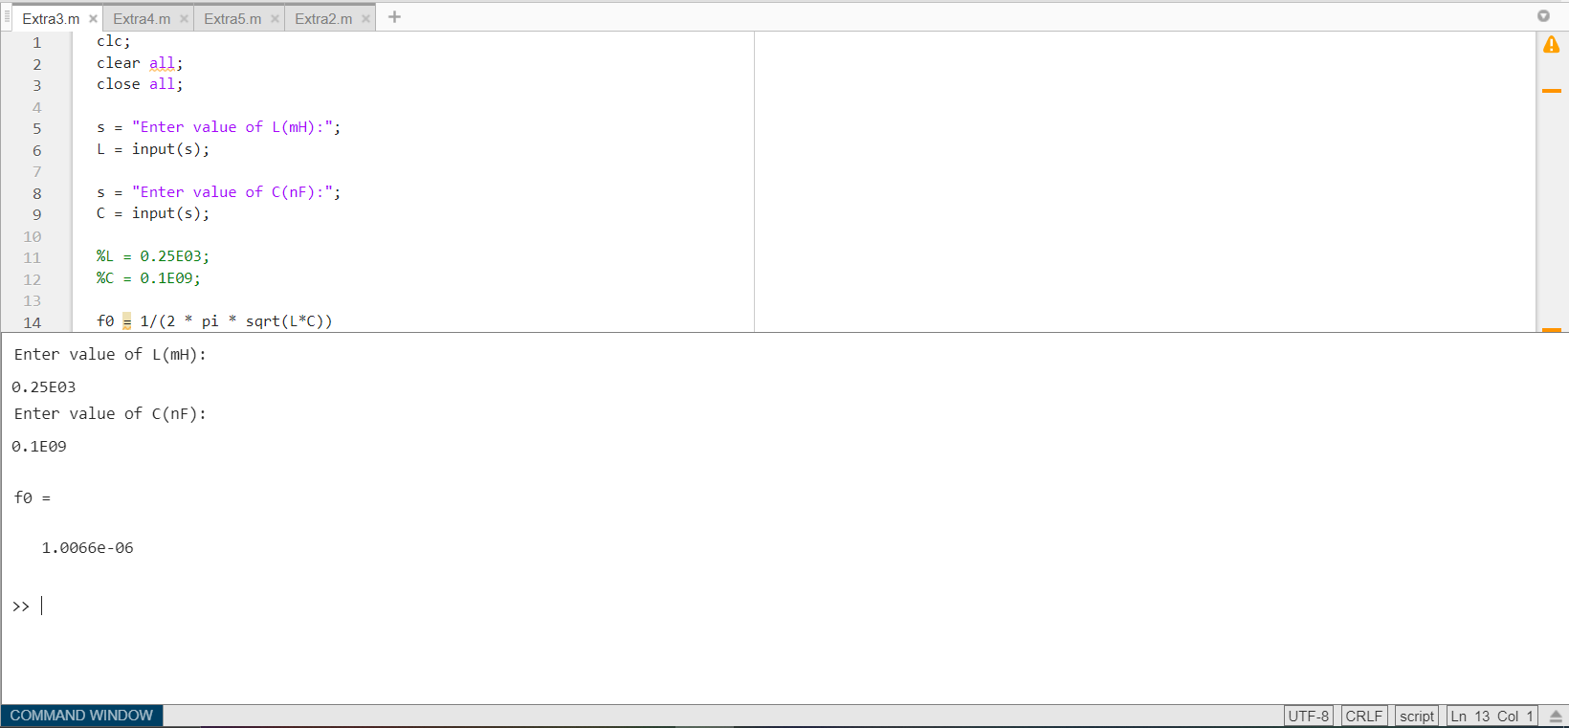

**Q-5.** The average (rms) voltage across the resistive load in above same figure varies as a function of frequency according to Equation



where *w=2пf* and *ƒ* is the frequency in hertz. Assume that *L* = 0.25 mH, *C* = 0.10 nF, R=50Ω, and *V0=*mV.

(*a*) Plot the rms voltage on the resistive load as a function of frequency. At what frequency does the voltage on the resistive load peak? What is the voltage on the load at this frequency? This frequency is called the resonant frequency ƒ*0* of the circuit.

(*b*) If the frequency is changed to 10% greater than the resonant frequency, what is the voltage on the load? How selective is this radio receiver?

(*c*) At what frequencies will the voltage on the load drop to half of the voltage at the resonant frequency?

**Code:**

clc;

clear all;

close all;

L=0.25E03

C=0.1E09

R=50

V0=5E03

f= 1:2:50

w=2*pi*f

Vr = (R * V0) ./ sqrt(R^2 + (w.*L - (1./(w.*C))).^2 )

plot(Vr,f)

title("Vrms vs f")

xlabel('Voltage')

ylabel('Frequency')

**Output:**

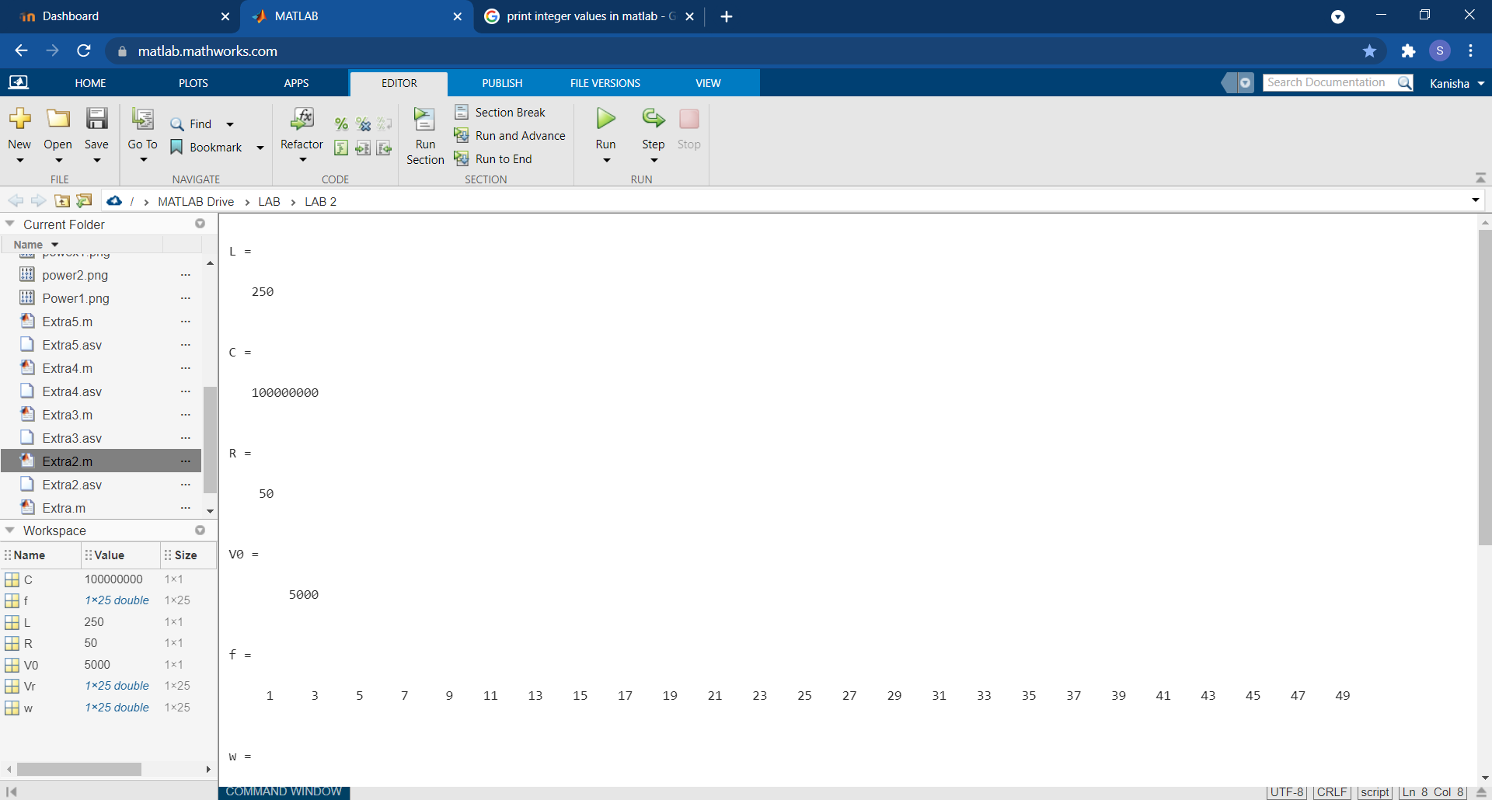

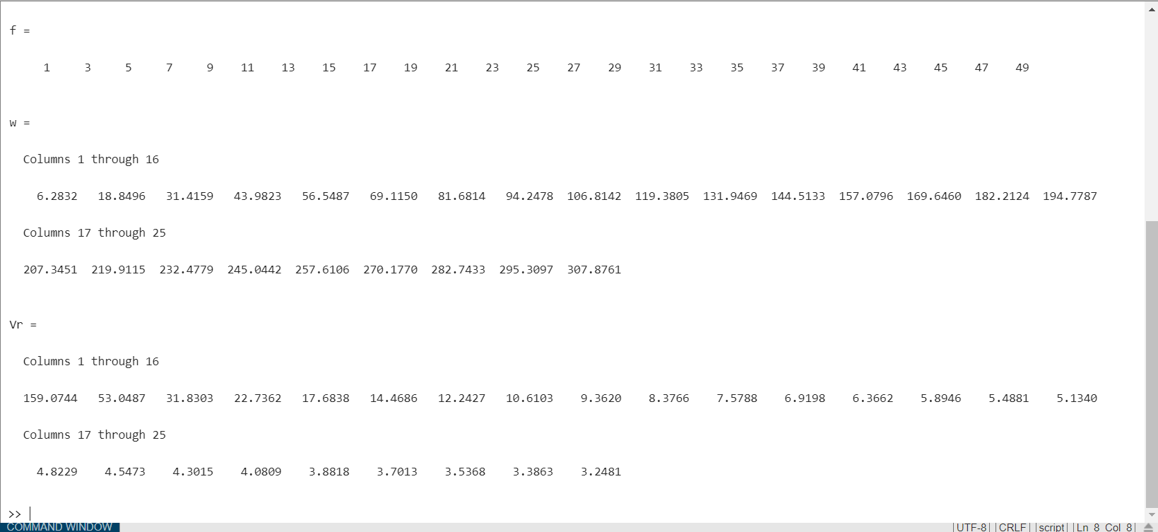

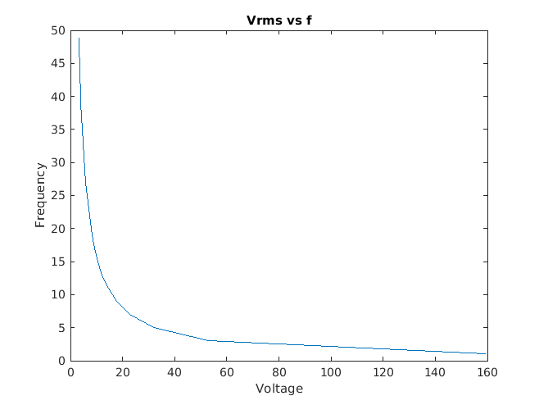

**Q-6.** An object moving in a circular path at a constant tangential velocity *v* is shown in below figure. The radial acceleration required for the object to move in the circular path is given by the Equation



where *a* is the centripetal acceleration of the object in m/s2, *v* is the tangential velocity of the object in m/s, and *r* is the turning radius in meters. Suppose that the object is an aircraft, and answer the following questions about it:

(*a*) Suppose that the aircraft is moving at Mach 0.85, or 85% of the speed of sound. If the centripetal acceleration is 2 g, what is the turning radius of the aircraft? (*Note*: For this problem, you may assume that Mach 1 is equal to 340 m/s, and that 1 g=9.81 m/s2.)

(*b*) Suppose that the speed of the aircraft increases to Mach 1.5. What is the turning radius of the aircraft now?

(*c*) Plot the turning radius as a function of aircraft speed for speeds between Mach 0.5 and Mach 2.0, assuming that the acceleration remains 2 g.

(*d*) Suppose that the maximum acceleration that the pilot can stand is 7 g. What is the minimum possible turning radius of the aircraft at Mach 1.5?

(*e*) Plot the turning radius as a function of centripetal acceleration for accelerations between 2 g and 8 g, assuming a constant speed of Mach 0.85.



**Code:**

clc;

clear all;

close all;

fprintf("Sr. Distance(m)")

a = 2 * 9.81;

v = 0.85 * 340;

r = (v * v )/a;

fprintf("\n1. %4.3f",r);

v = 0.85 * 340;

r = (v * v )/a;

fprintf("\n2. %4.3f",r);

v = 0.5 * 340 : 10 : 2*340;

r = (v .* v )./a;

figure(1);

plot(v,r);

xlabel("Velocity m/s");

ylabel("Distance m");

a = 7 * 9.81;

v = 1.5 * 340;

r = (v * v )/a;

fprintf("3. %4.3f",r);

a = 2*9.81 : 10 : 8*9.81;

v = 0.85 * 340;

r = (v * v )./a;

figure(2);

plot(a,r);

xlabel("Accelaration m/s^{2}");

ylabel("Distance m");

**Output:**

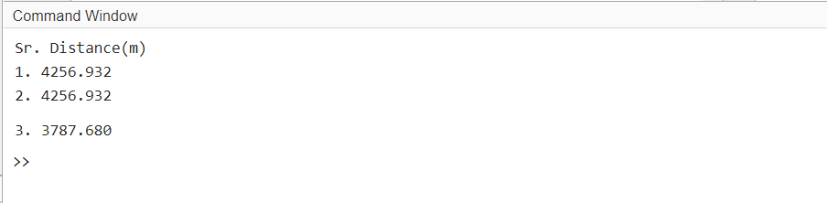

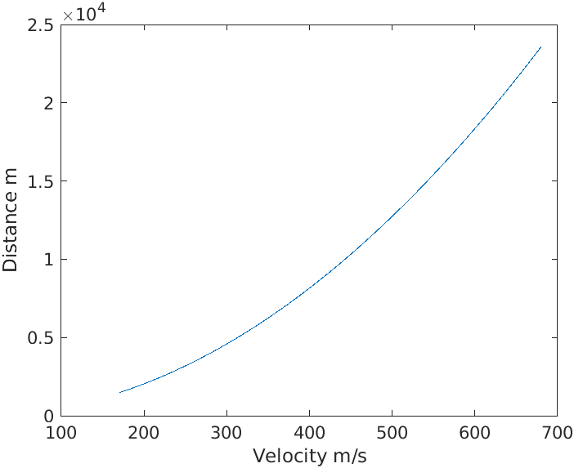

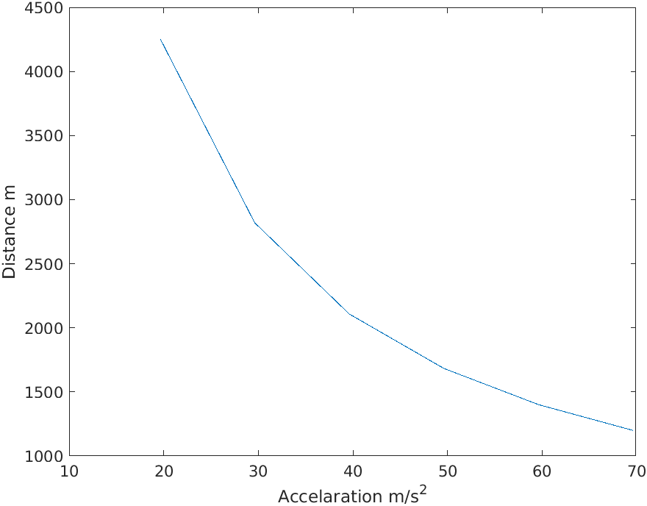

**Conclusion:**

From this experiment we came understand different ways to plat graphs and how to declare a variable. We even understood about the execution flow of the expression when brackets are taken under the case. We learnt about the array multiplication, different inbuilt functions like zeros and ones, while we got acquainted with the vector multiplication.